**SuperSonic Volleyball**

Team work project for JavaScript UI & DOM course June 2014

## A project of: Team "Krusty the Clown"

## 1. Team members

***- not participated: Nikolay Karachorov (specnaz), Ivan Kashukeev (jquery) and Julien Manov (JulienManov)***

|  |  |  |
| --- | --- | --- |
| **Name** | **Username** (from the student system) | **Github user** |
| Plamen Stepanian | flame78 | flame78 |
| Rosen Todorov | RosenTodorov | RosenTodorov |

# 2. Project explanation

## Summary

The game is based on the game Arcade Volleyball. In our game we use the two SuperSonic’s actors. They play volleyball against each other on the beach. They can walk, run, jump and push the ball.



<http://upload.wikimedia.org/wikipedia/en/d/d7/Arcade_Volleyball_%28gameplay%29.gif>

## More details

1. **The Game**

The SuperSonic’s player can walk and run **Right/Left** with the arrows and Jump on the left with **ArrowUp & Left** and on the right with **ArrowUp & Right**. Every SuperSonic player has score and the purpose of the game is to play volleyball against each other and make more points. The first player is Artificial intelligence.

***Images:***

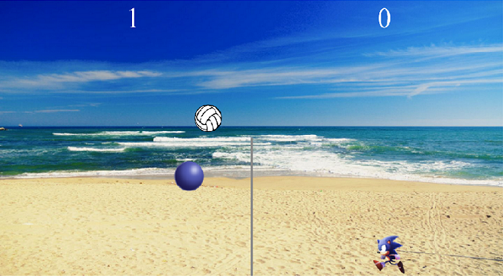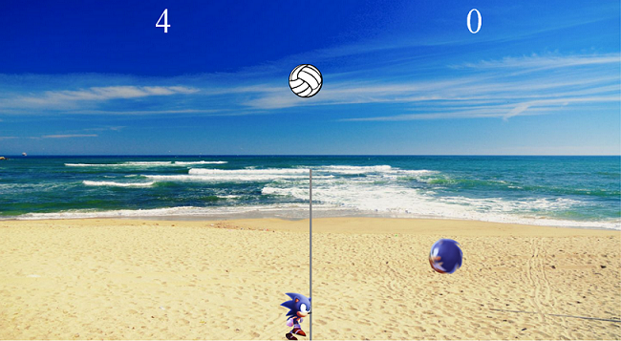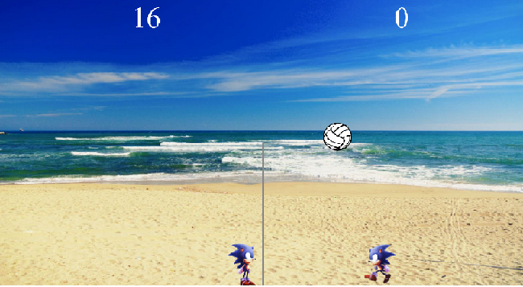

1. **Used technologies**

The most of the characters in the game are animated using SVG and KineticJS. For the background we use DOM manipulation. The ball and SuperSonic’s players run on physical laws with acceleration and gravity. When resizing the window automatically changes also the game. The game can run on devices with shearing capacity from 40 to 4000 resolution.

# 3. GitHub Repository

# <https://github.com/flame78/Arcade-Volleyball.git>

# 4. Other information

* N/A